HR@UW Competencies Cohort Program

Declaration of Interest

Thank you for enrolling in the cohort!
Your answers here will help us to learn more about who will be joining the cohort. Enrollment is on a first come, first served basis until max capacity (18) is reached. Discuss your interest with your supervisor/manager, and if they are supportive and agree to the time commitment: Complete this form in entirety.
Important note—Participation requires completion of your first six months, or initial probationary period (whichever comes first). Contact HR CoP if there are circumstances that you’d like for us to consider.
Name: |  | Role:
Email: |  | Div./Dept.:
Phone: |  | Manager:
Today’s Date: |  | Time in role:
Comments?

Please type your responses in the expandable boxes beneath each question:
How long and in what capacities have you worked in HR? Distinguish between UW and outside UW, if applicable.

How long have you worked at UW? In what roles and departments/ divisions?

Why are you interested in participating in the cohort at this time?

Do you have specific goal(s) for your time in the cohort?

How might this program equip you to engage further with the HR & Payroll community at UW-Madison?

The program’s success requires cohort members’ engagement. The monthly time commitment requires a minimum of six (6) hours every four weeks for the duration of the seven-month program:
3.5 hours—attending in-person sessions (Jan 12, Feb 9, Mar 9, Apr 6, May 4, Jun 1, Jun 29, Jul 27)
1.5 hours—doing assigned readings related to each module
1 hour—participating in online discussions

The 360 Inventory:
There are seven HR competencies—Equity, Inclusion, and Diversity (EID); HR Functional Knowledge and Expertise; Collaboration; Ethics and Integrity; and Change Management; Problem Solving; and Execution.
The purpose of the 360-inventory is to give you an opportunity to identify which of the seven competencies you might focus on during the seven-month cohort experience. Along with your own evaluation, you’ll provide a minimum of four/maximum of seven references who will also provide feedback.
The results offer a visual mechanism to compare your self-perception of competence with the perceptions that others have of your competence. Results contrast “SELF” (blue) with aggregated “OTHERS” (orange):
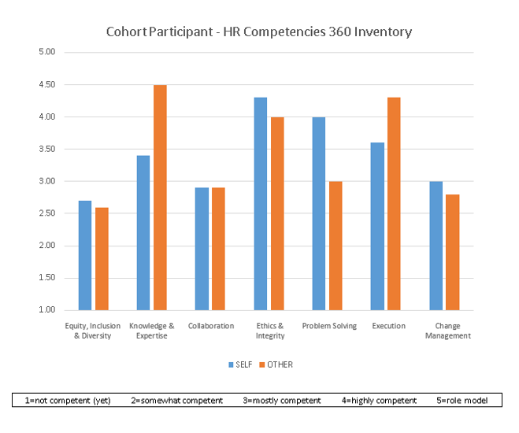
The inventory draws on competency definitions in the rubrics, which operationalize competence. Definitions and rubrics can be found online on the HR Communities of Practice website.
Decide whom you’ll ask to complete a “360” on your behalf. They do not have to be in HR themselves, but should know you well enough to evaluate you. Your manager/ supervisor is required (person #1). Others can include:
  - Direct reports (at least one is required if you supervise others)
  - Teammates
  - HR colleagues who know your work
  - Your divisional HR liaison if you work at the department-level, or an OHR colleague if you’re division-level
  - Customers whom you have served
  - Others at the university with whom you have coordinated work on committees, collaborative projects, etc.

Consider: Who sees the results of your work? Who sees how you work? The results will be shared only with you. To get the most out of your 360, you’re encouraged to include people who have experienced your work in different ways rather than choosing people who ‘like’ you.
Indicate your 360 references below:
 | Name of others (minimum 4) who will submit feedback for you: | Relationship to You  (colleague, customer,  direct report, etc.) | The person’s email address
1 |  | Manager/Supervisor
2
3
4
(5)
(6)
(7)

Once you have decided whom you will ask, and before submitting this form, let your references know that you’d like them to complete a “360” as part of your participation in the HR Competencies Cohort Program. Tell them that:
  - The Qualtrics survey generally takes no more than 10-15 minutes.
  - Their feedback will be anonymous; you will not see their feedback individually, but instead will see 360 feedback in aggregate form (“Others”), with feedback from a minimum of four (including them) “Others” for purposes of comparing to your own assessment (“Self”).

Sign and invite manager/supervisor to sign:
PARTICIPANT:
☐ I have read the Overview of the HR Competencies Program and understand the commitment required.
☐ I commit to attending all cohort sessions, doing the assigned readings, and participating in all discussions, to the best of my ability, with the understanding that the success of the cohort experience relies on each cohort member’s commitment to show up for one other.
Your Signature: |  | Today’s Date:

SUPERVISOR/MANAGER:
☐ I have read the Overview of the HR Competencies Program and understand the commitment required (minimum 6 hours/every four weeks for the duration of the seven-month program).
☐ I agree to support my team member’s ability to attend all sessions, do readings, and participate in discussions.
Manager’s Signature: |  | Date:

PARTICIPANT: Once form is signed by you and your supervisor/manager, email this form and your up-to-date resume to hr_communities_of_practice@ohr.wisc.edu. Copy your supervisor/manager when you send that email.

