Fellow-Trainee Overpayment Adjustment - SGA Additional Pay code instructions

The SGA Add’l Pay code will be used to adjust Fellowship and Trainee compensation that may exceed a sponsor’s awarded amount due to the biweekly pay schedule and appointment duration.
Calculate the adjustment amount using the Fellow/Trainee Calculator button ‘Print F/T Calc Report’ in JEMS-Hire on the Job tab
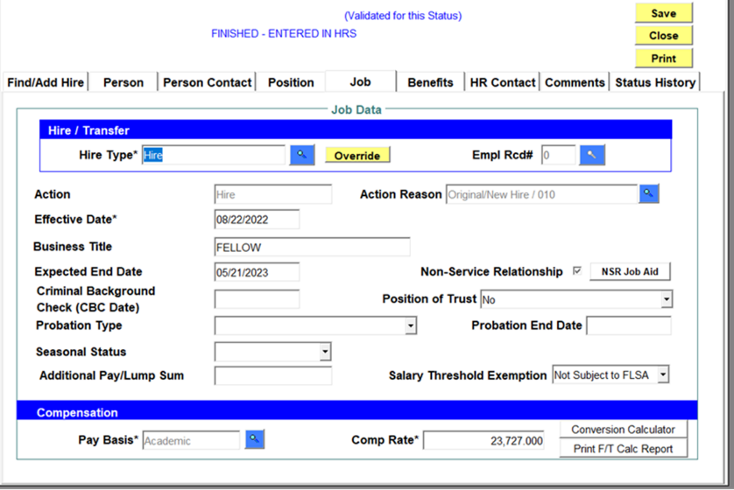

Enter the adjustment, if needed, in HRS
- Navigate to the Workflow Add’l Pay Create screen in HRS.
Main Menu > Payroll for North America > Employee Pay Data USA > Workflow Add’l Pay Create
- Select the Add a New Value tab
- Enter the following:
  - Empl ID
  - Empl Record
  - Select the SGA earnings code
  - Using the calculator enter the pay period start date with the first SGA Adjustment – Note that SGA adjustments are taken on full pay periods
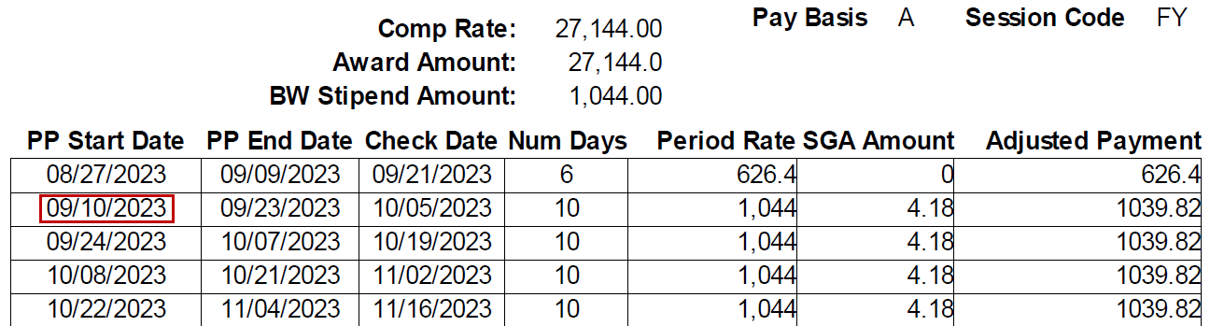
  - Click Add
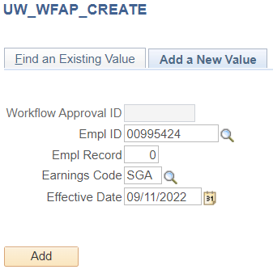
- Addl Seq Nbr should be 1
- End date will be the last day of the pay period with an SGA adjustment
- The earnings amount will be SGA Adjustment - this is entered as a negative amount in HRS
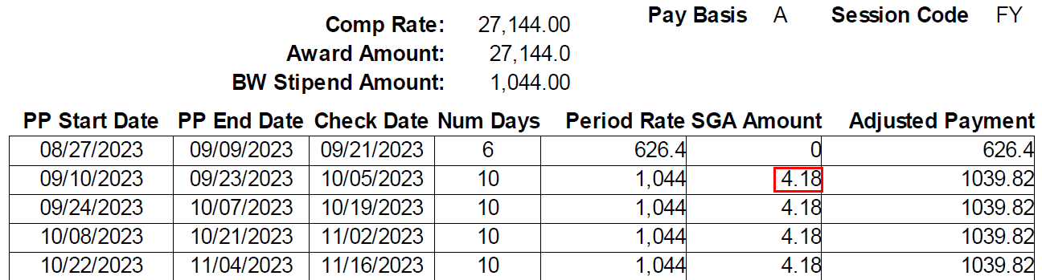
- The goal amount will be the total of the SGA Adjustment - this is entered as a negative amount in HRS

- Make sure that the Applies to Pay Periods has First, Second and Third checked.
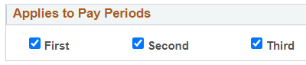
- Enter the Description
[NAME] is receiving biweekly negative adjustments on their fellowship/trainee appointment due to a payroll discrepancy between the amount awarded by their funding sponsor and UW’s biweekly payroll schedule.
- Click Submit
- Add’l Pay adjustment requires approval by the level 1 and level 2 approvers
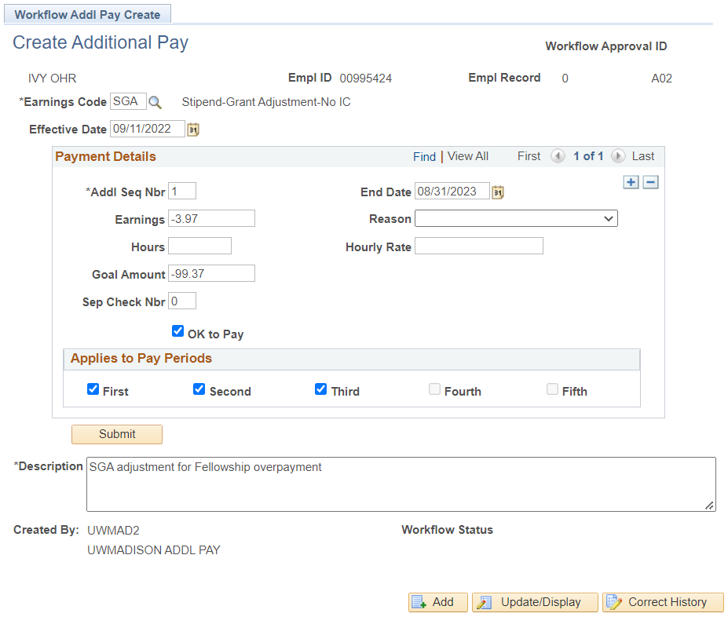
Solution for Underpayments
- Underpayment - amount being paid is below the stipend rate – sometimes see this with one semester payments
- Lump sum payment at or near the end of the semester – we recommend on the last pay period
- Paid thorough Add’l Pay
- Earnings Code – STL
- Explanation of payment in Description field should include explanation of the stipend award amount, amount paid through biweekly, and that this is the amount to reach the stipend award amount
Best Practice Reminders
- Add’l Pays should be fully approved before the pay sheet creation of the first pay period with the add’l pay
- HRS cannot do retro add’l pays as a series
  - SGA adjustment amounts should be adjusted to be spread out over the appointment
- Review the Payroll Edit or Review Paycheck to verify adjustments are processing as expected
  - Remember these will be negative amounts
- When appointments are terminated early, the total paid and adjustment will need to be reviewed
  - Add’l Pay entry should be updated to reflect the final adjustment or stopped if no additional adjustments are needed
- Periodic auditing is recommended using the Fellow/Trainee Audit report in JEMS-Hire.
  - Use Department field and Job Date Range to set report parameters
