Completing Hires in JEMS HIRE – Multi Hire

JEMS Multi Hire is a new functionality that can be used to hire multiple employees into a position whose job attributes are exactly the same for all employees. Examples include hiring ten Teaching Assistants at 33% in the Department of Chemistry for the fall semester or hiring for the basketball camp in Athletics.
This functionality does not include any positions hired via PVL or waiver. It is likely some schools/colleges/divisions will not have hires that would be entered via JEMS Multi Hire.

To get started, click the Multi Hire button from the JEMS Hire Main Menu.
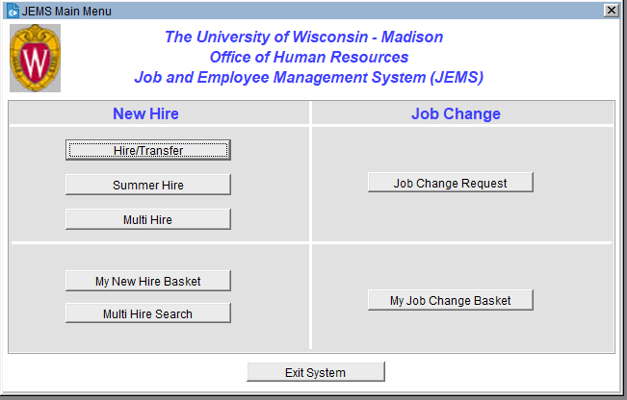

Complete the fields in the Position tab. All values on this tab must be the same for every individual hired in this Multi Hire transaction, with two exceptions.* A few notes about some of the fields:
- Effective Date: This is the date the employees will begin the job.
- Expected End Date: If continuity is 02A, 02B, 02C, 05A, 05B, or 05C, Expected End Date is required.
- Empl Class:
  - The Empl Class for Academic Staff is only available to select Camp Counselor (OE010) and the Clinical Adjunct Professor title series (IC005, IC006, IC007).
  - The Empl Class for Temporary Employee (CL) is only available to select Crowd Control Officer (TE007).
  - The other available Empl Classes are ET, OT, and SA.
- *Business Title: This title copies from the Position tab to each Person in the Multi Hire transaction. You can change the business title for each individual in the Person tab as needed.
- FTE: Full-time equivalent. Entered as decimal. Reference: KB 18202
- *Reports To: Enter the supervisor’s Empl ID. Click on the magnifying glass to select the correct Job/Position Number of the supervisor. Leave blank if you prefer to add a Reports To via the Person tab for individual employee(s).
- Continuity: Click the magnifying glass to select. Reference: KB 16903
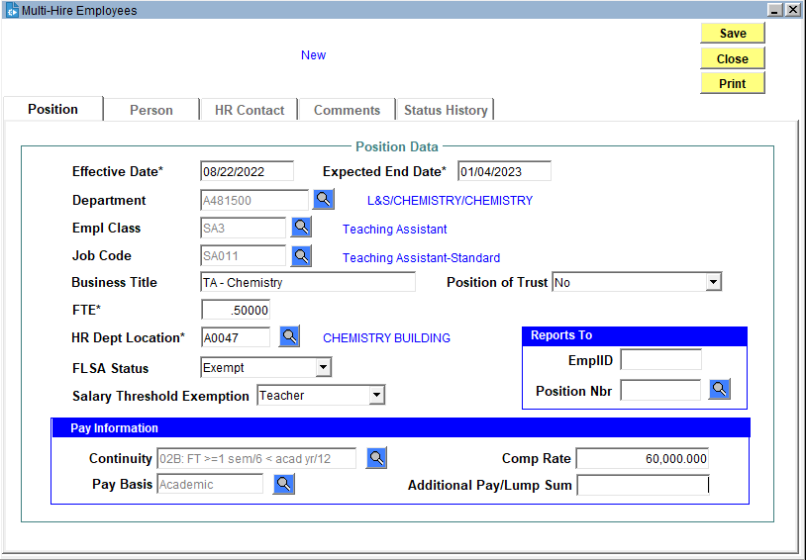
When you click the Save button, you will receive a Status Change Successful message:
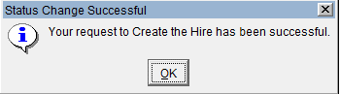
Click OK. The transaction will move to Entered status, and the Person, HR Contact, Comments, and Status History tabs become available.
On the Person tab, enter employee information for each individual to be hired in this transaction. Remember to check both HRS and Legacy data sources prior to entering any new person (i.e., any employee without an Empl ID).
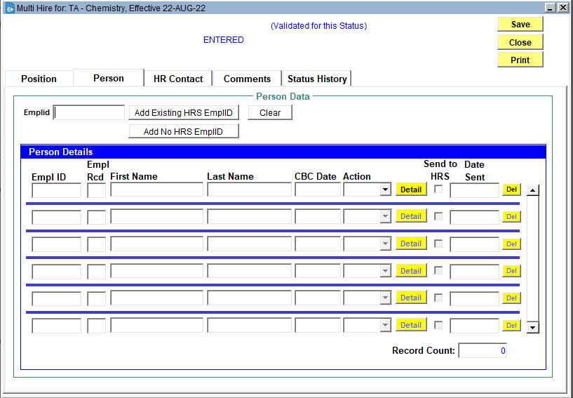
- To add an employee with an existing Empl ID, enter the Empl ID in the Emplid field and click the Add Existing HRS EmplID button.
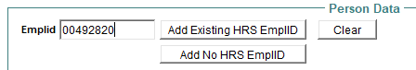

You will be prompted to select from the Jobs List for the employee:
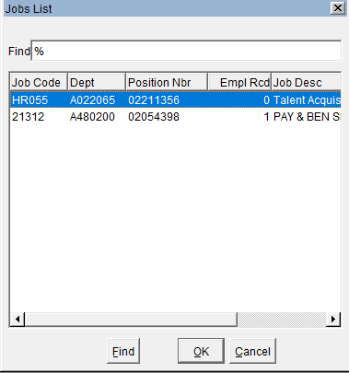
  - If this transaction will be a Transfer for the selected employee, select the Empl Rcd on which the transfer should be processed. Click OK.
    - Transfer is an action used when an employee moves from an active appointment to a new appointment without a break in service. An employee who never holds more than one appointment at a given time (no concurrent appointments) should only ever have an Employee Record 0 in HRS.
  - If this transaction will be a Hire for the selected employee, select the inactive Empl Rcd that you want to hire the person onto. Click OK.
    - If all Empl Rcds listed are active in HRS, the system still asks you to select from the jobs list. Select any empl rcd - JEMS will not overwrite the job in HRS but will instead create a new empl rcd.
  - You will have an opportunity to select Hire or Transfer before sending to HRS.

The employee will now appear in the Person Details list. Select Hire or Transfer from the Action dropdown:
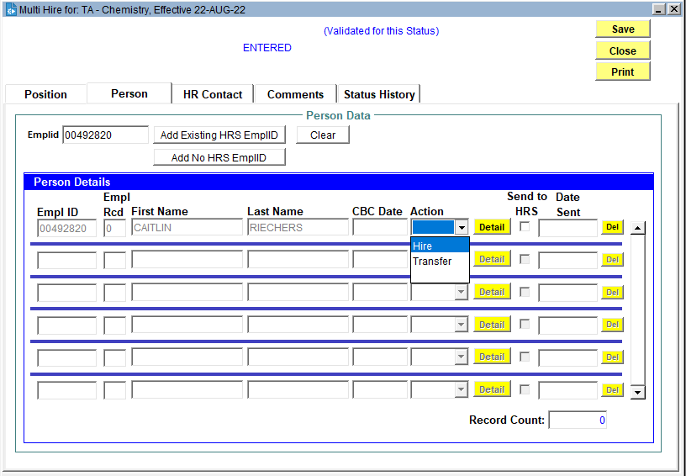
- To add an employee who does not have an Empl ID, click the Add No HRS EmplID button.
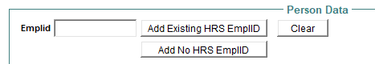

Complete fields on the Person tab.
- First Name, Last Name: Must be legal name
- Individual Business Title: The Business Title from the Position copies to each individual Person tab. Change this field as needed. When the individual hire is sent to HRS, it will send the Individual Business Title. There is a 30-character maximum for this field.
- Reports To: Enter the supervisor’s Empl ID. Click on the magnifying glass to select the correct Job/Position Number of the supervisor.
- If person is a foreign national, check the “Foreign National” box. This will populate the HRS visa page and prompt the creation of a Glacier account. Foreign nationals on UW payroll must have a Glacier account and enter their immigration information. A higher tax rate will be applied if the relevant information is not added to HRS, and the Glacier account completed by the employee.
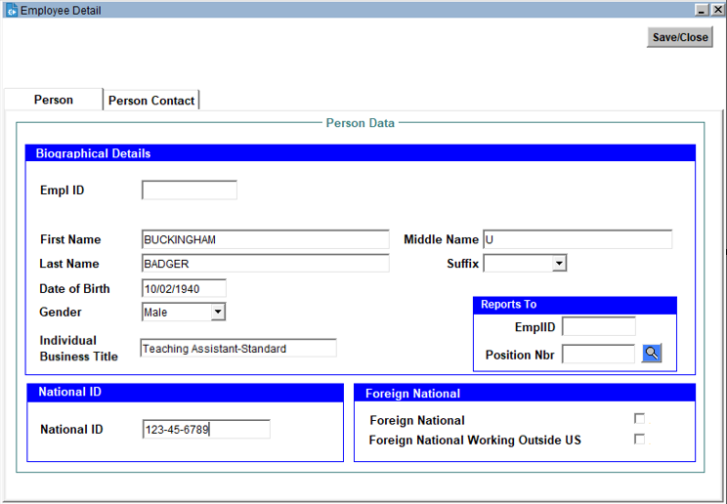

Complete fields on the Person Contact tab. Click the Edit/View Address Detail button to enter address information.
- Also add Office Address
- For foreign national employees who do not yet have US address, use office address for home address.
- For new foreign national employees, enter an e-mail address in the Home Email field. An automated e-mail with instructions for creating a Glacier account will be sent to this address.
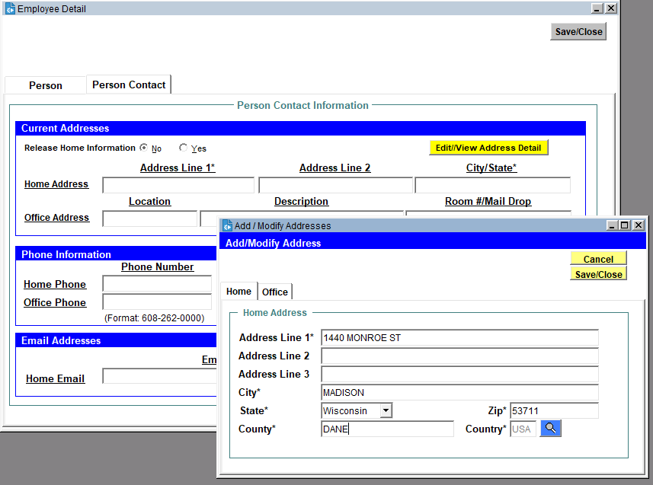

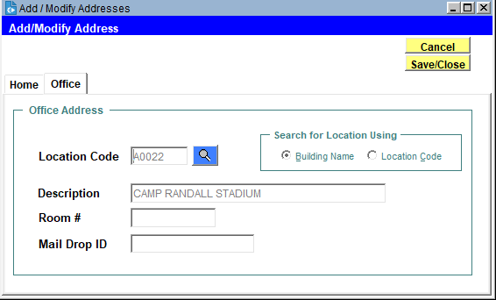
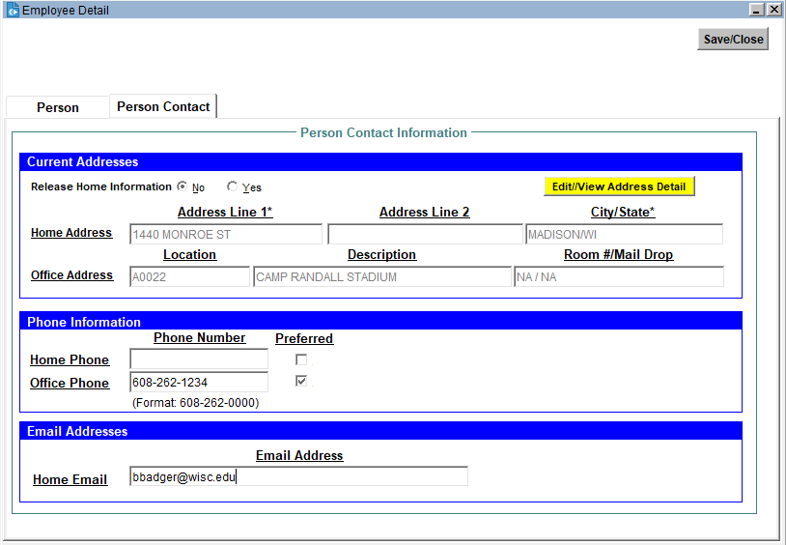

Click the Save/Close button. The new employee will now appear in the Person Details list. Select Hire from the Action dropdown.
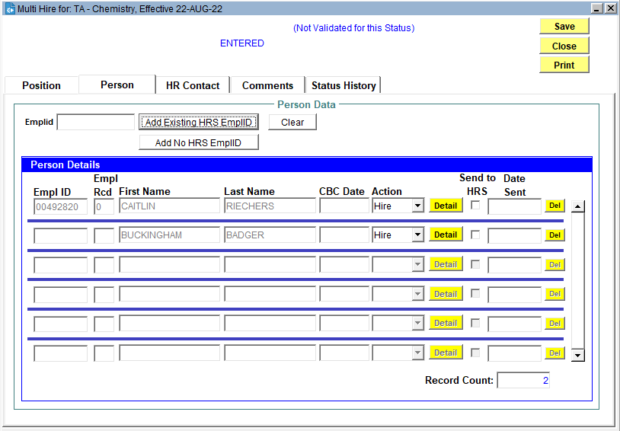

On the HR Contact tab click the Add Contact button to complete the primary contact. Click the Done button to save the contact. If this is a paid position, also complete the Funding Contact. 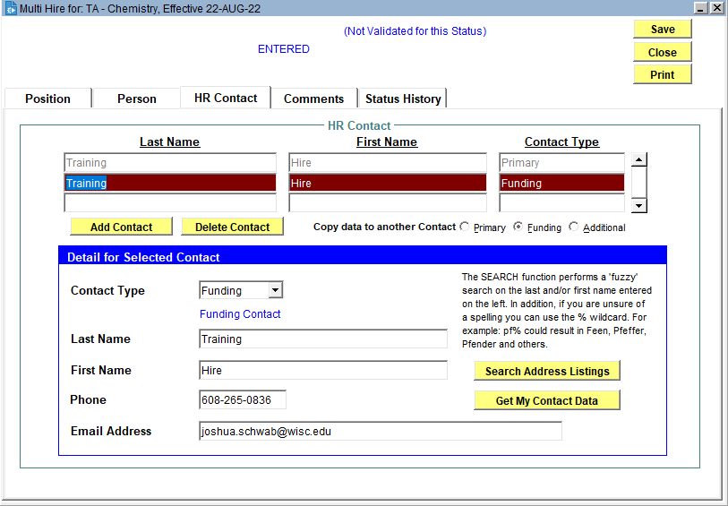

On the Comments tab, click the Add Comment button to communicate information to HR as needed. Entry in this tab is not required.
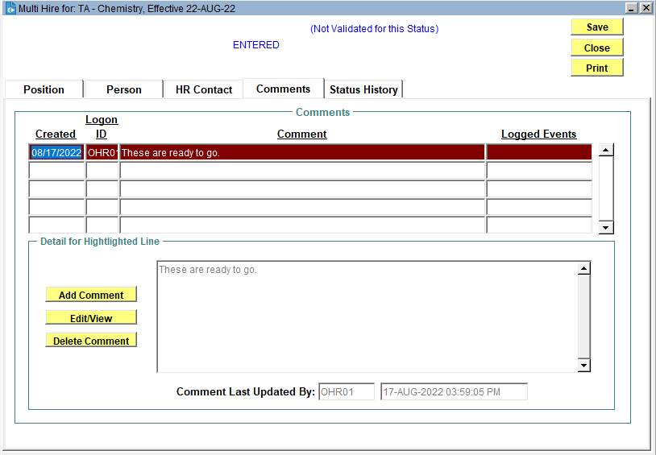

When you* are ready to send one or more hires to HRS, return to the Person tab and check the Send to HRS box for each hire you would like sent to HRS. You do not have to send all hires at one time.
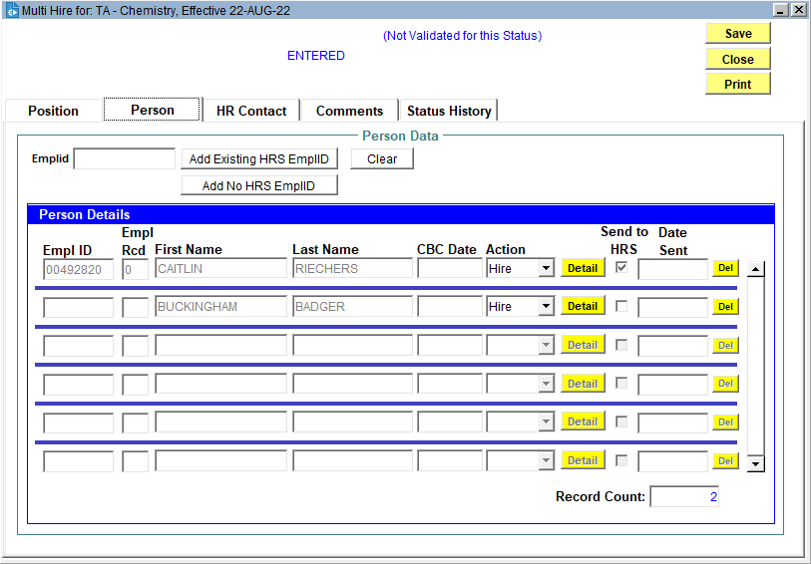

To delete an employee row that has not been sent to HRS, click the Del button. You cannot delete an employee row that has already been sent to HRS.
*Only division-level HR staff can check the Send to HRS box and Send to HRS via the Actions menu. If your division is having department-level HR set up the hires, you must create a process outside of JEMS Hire that communicates when hires are ready to be sent to HRS so that division HR knows to log in and push the hire(s) to HRS.

From the Actions menu, select Send to HRS. Only the checked hires will be sent to HRS.
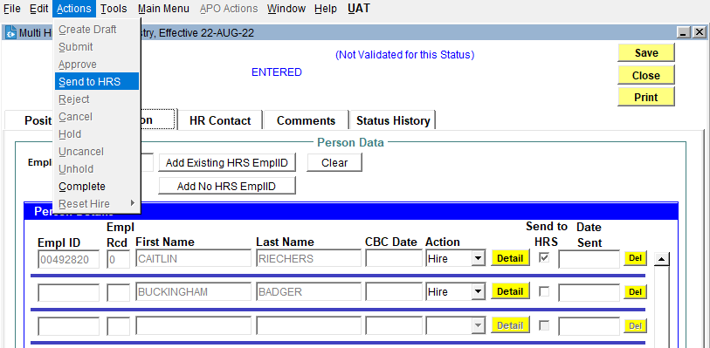
JEMS will check the transaction for errors. If there are none, you will be asked for approval confirmation:
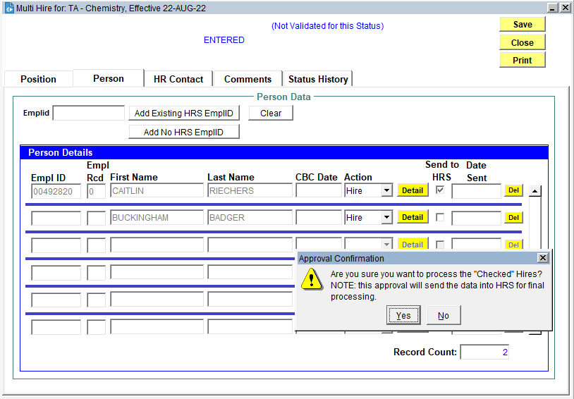

The Date Sent will show in the Person tab after a hire is sent to HRS. The contacts in the HR Contact tab will receive an email for each hire when it is successfully processed in HRS, or if an error prevented a hire from successfully processing.
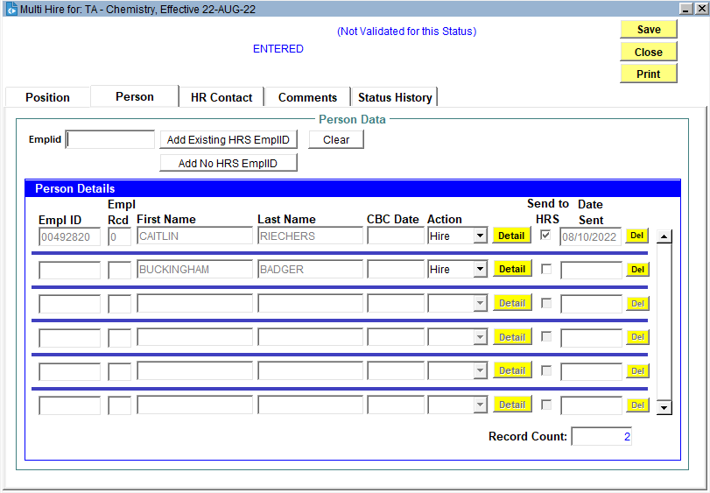

If you want to review the details of an individual hire that was processed in a multi hire transaction, search via the My New Hire Basket.
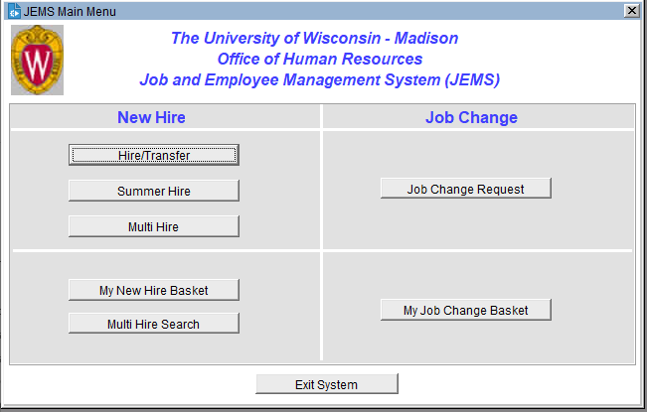
For each individual hire sent to HRS via multi hire, a full JEMS Hire transaction is created that mirrors JEMS Hire entries done via normal processing. This is to ensure a proper audit trail for the hire. In the event of an error during processing, troubleshoot by reviewing the individual transaction that is created upon sending a hire to HRS via a multi hire transaction.

You can return to a multi hire transaction later to add more hires or edit/delete previous hires that have not yet been sent to HRS. From the JEMS Hire main menu, click the Multi Hire Search button.

Use the search fields to find the transaction you need. Click on the desired transaction to highlight it and click the View or Modify button.
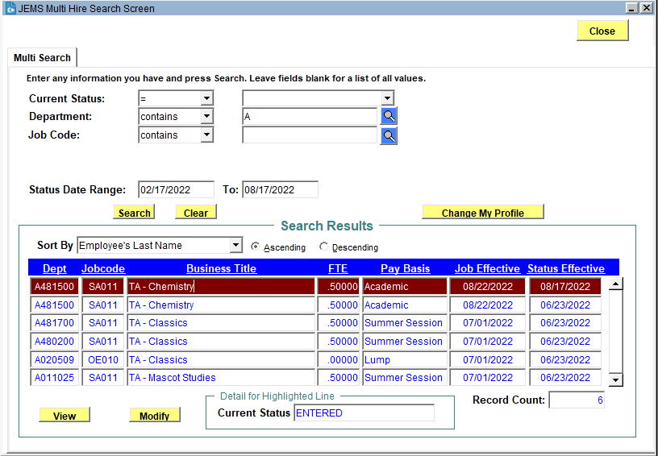

- To add another hire – follow the procedures starting on page 3
- To edit an existing hire that has not been sent to HRS – Change the Action dropdown and/or click the Detail button
- Delete an existing hire that has not been sent to HRS – Click the Del button

There is not a way to move an individual hire from one Multi Hire transaction to another. If you need to move a hire, you must delete it from one Multi Hire transaction and add it to a different Multi Hire transaction.

Transaction Status
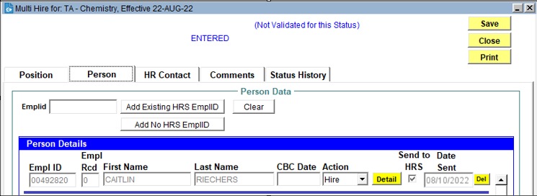
When the department creates a new Multi Hire transaction, the status of the transaction is “Entered”. That status remains “Entered” until the division closes the transaction. Upon closing, the status is changed to “Finished - Entered in HRS”, after which no more additions, edits or deletions can be made in the transaction.
When the division pushes a Multi Hire entry to HRS, JEMS creates a new individual entry for that hire. The status of that individual entry becomes “TRE Approved-Sent to HRS,” and the individual entry can be found in the regular JEMS Hire New Hire Basket.
- If that individual entry is error-free, the job will load to HRS and the JEMS Hire status of that individual entry will change to “Finished-Entered in HRS”.
- If that individual entry contains an error that causes HRS to reject the hire, that entry’s status will change back to “Department Approved”, and the entry will be found in the division’s regular JEMS Hire New Hire Basket (not in Multi Hire). An automated e-mail with the error message(s) is sent to the division and department. The division must then evaluate the individual transaction to fix the error and repush the hire to HRS.

From the Person Details list, the appearance of the Date Sent field can help determine the current status of individual hires:

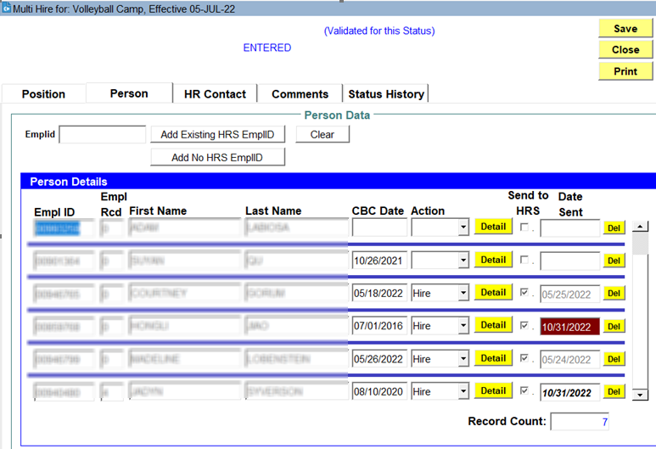

Highlighted = error
Bold italic = in process

When all hires have been made on a Multi hire transaction, the Division JEMS user can change the transaction’s status to Complete. From the Actions menu, select Complete.
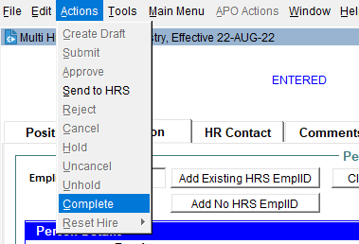
The transaction status will change to Finished – Entered in HRS.

